Pig Activity -

Vi files for –

episodeIV_dialouges.txt

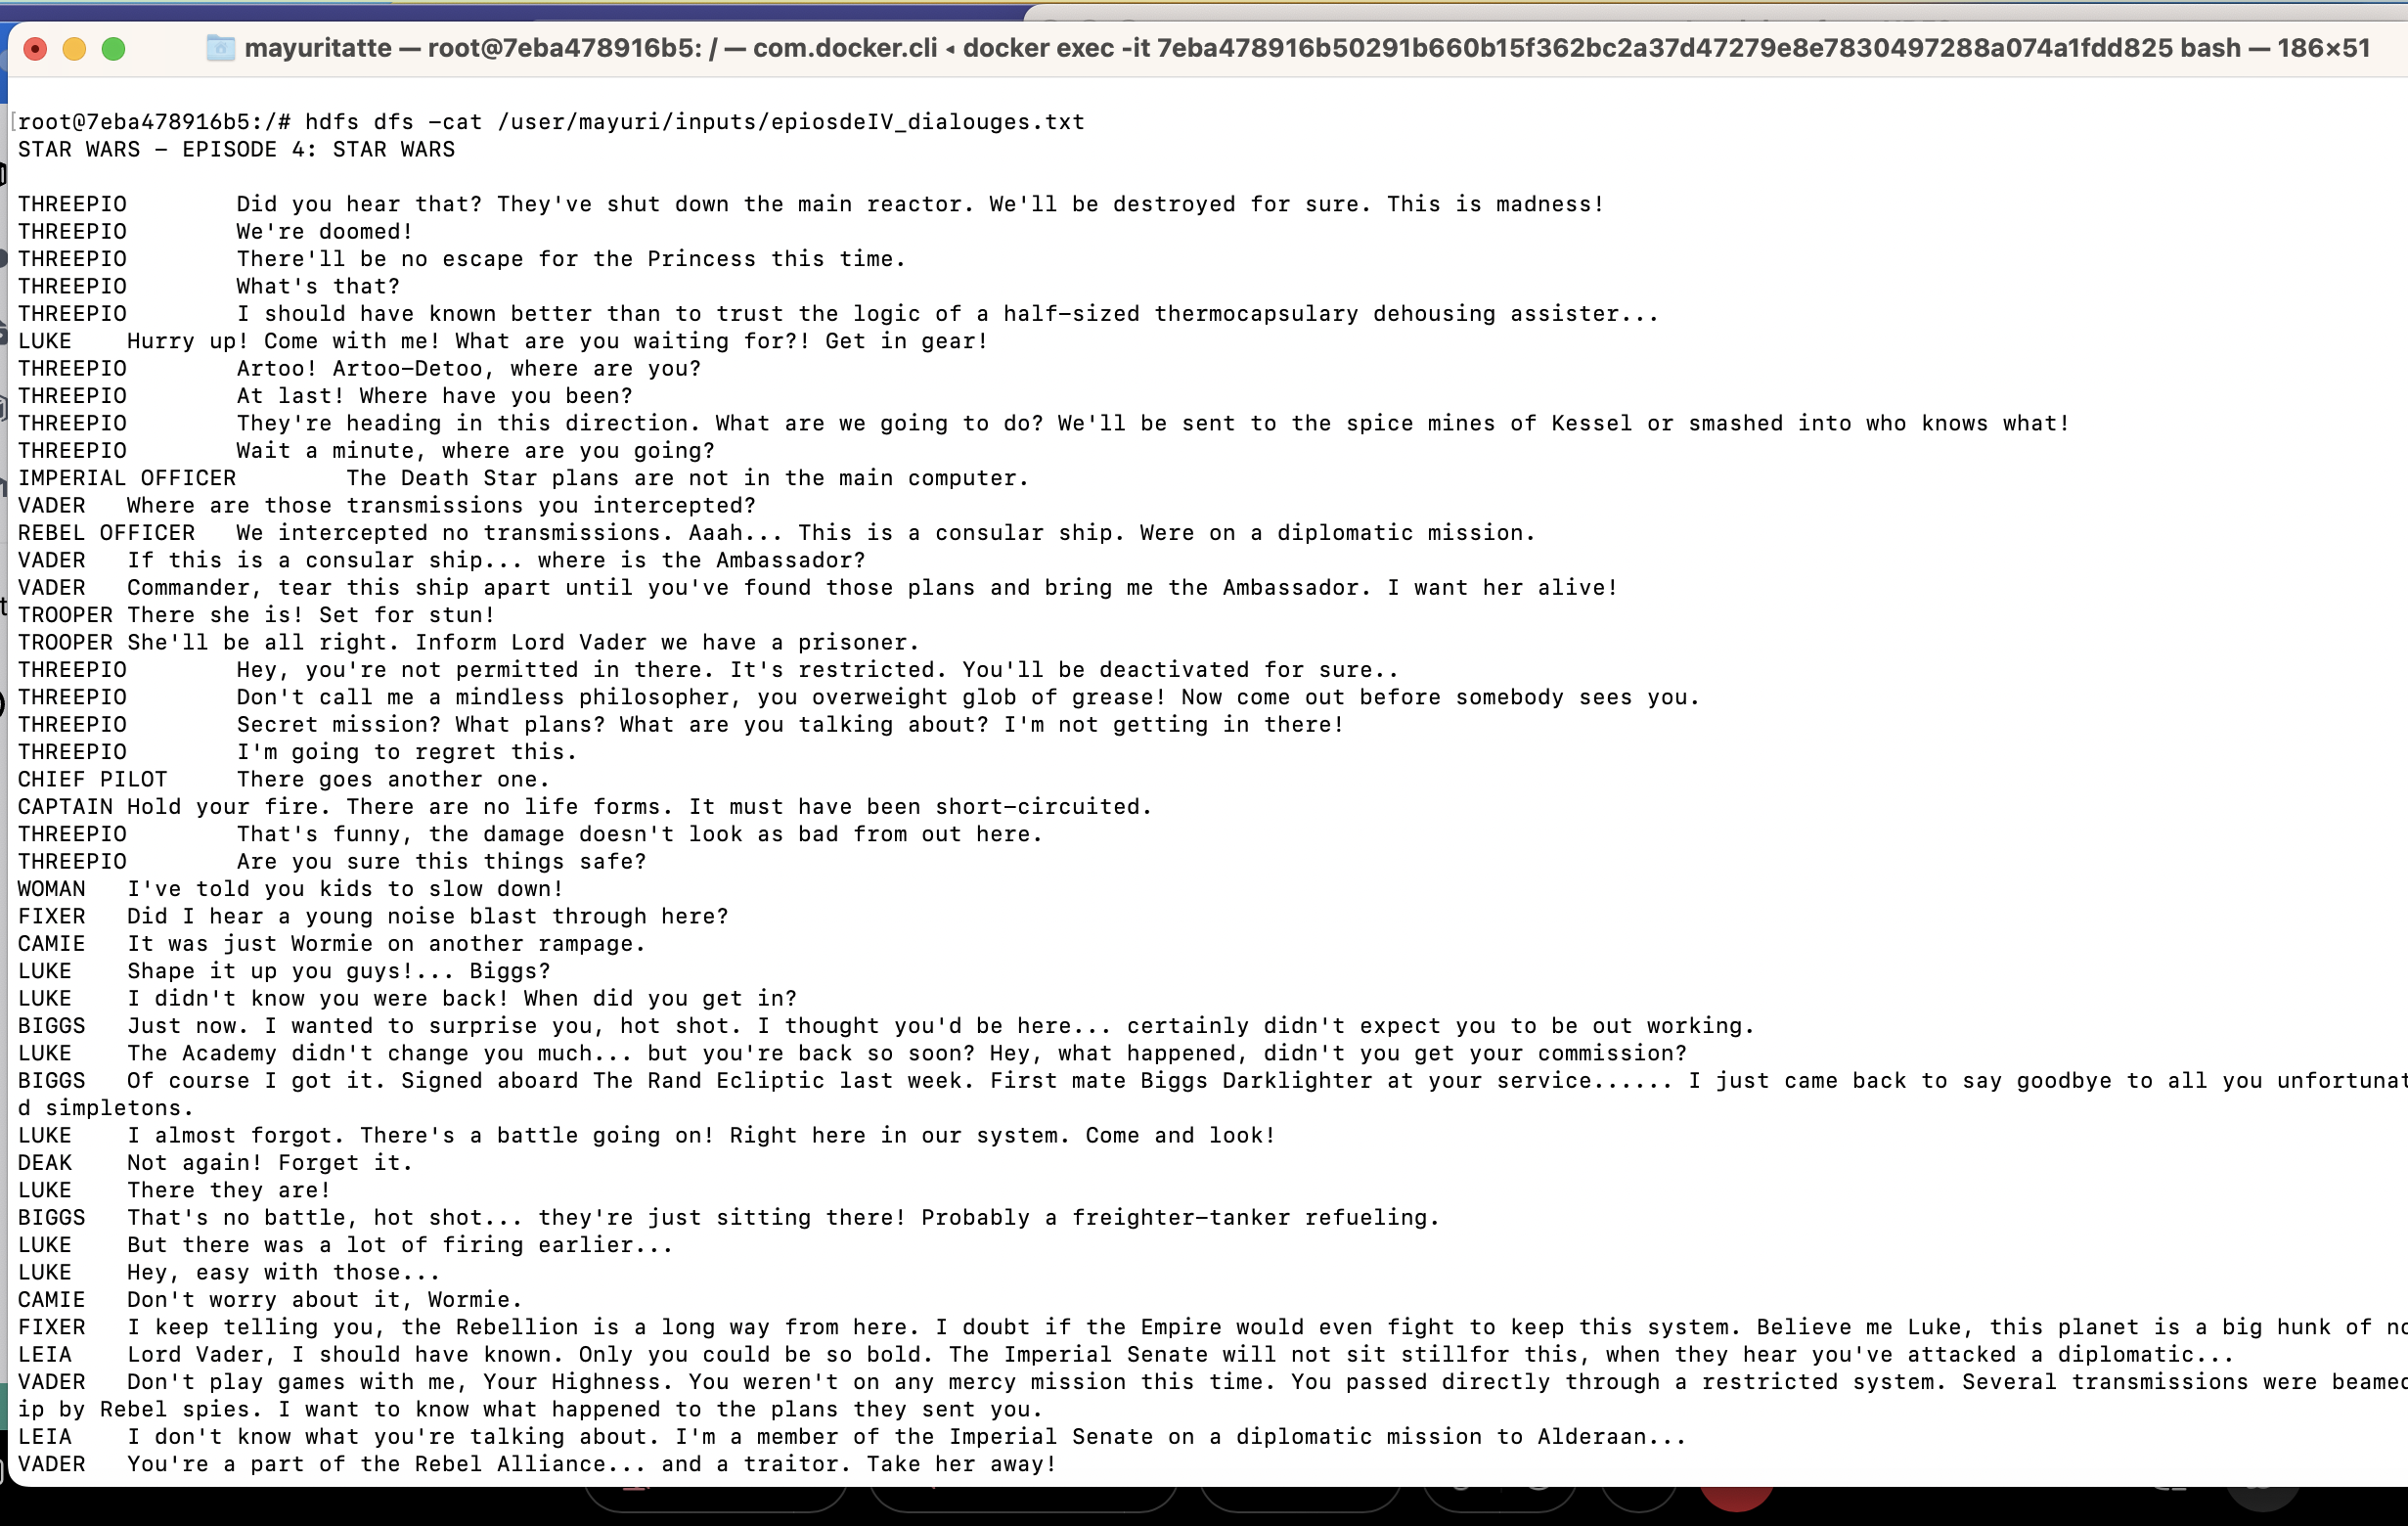

episodeV_dialouges.txt

episodeVI_dialouges.txt

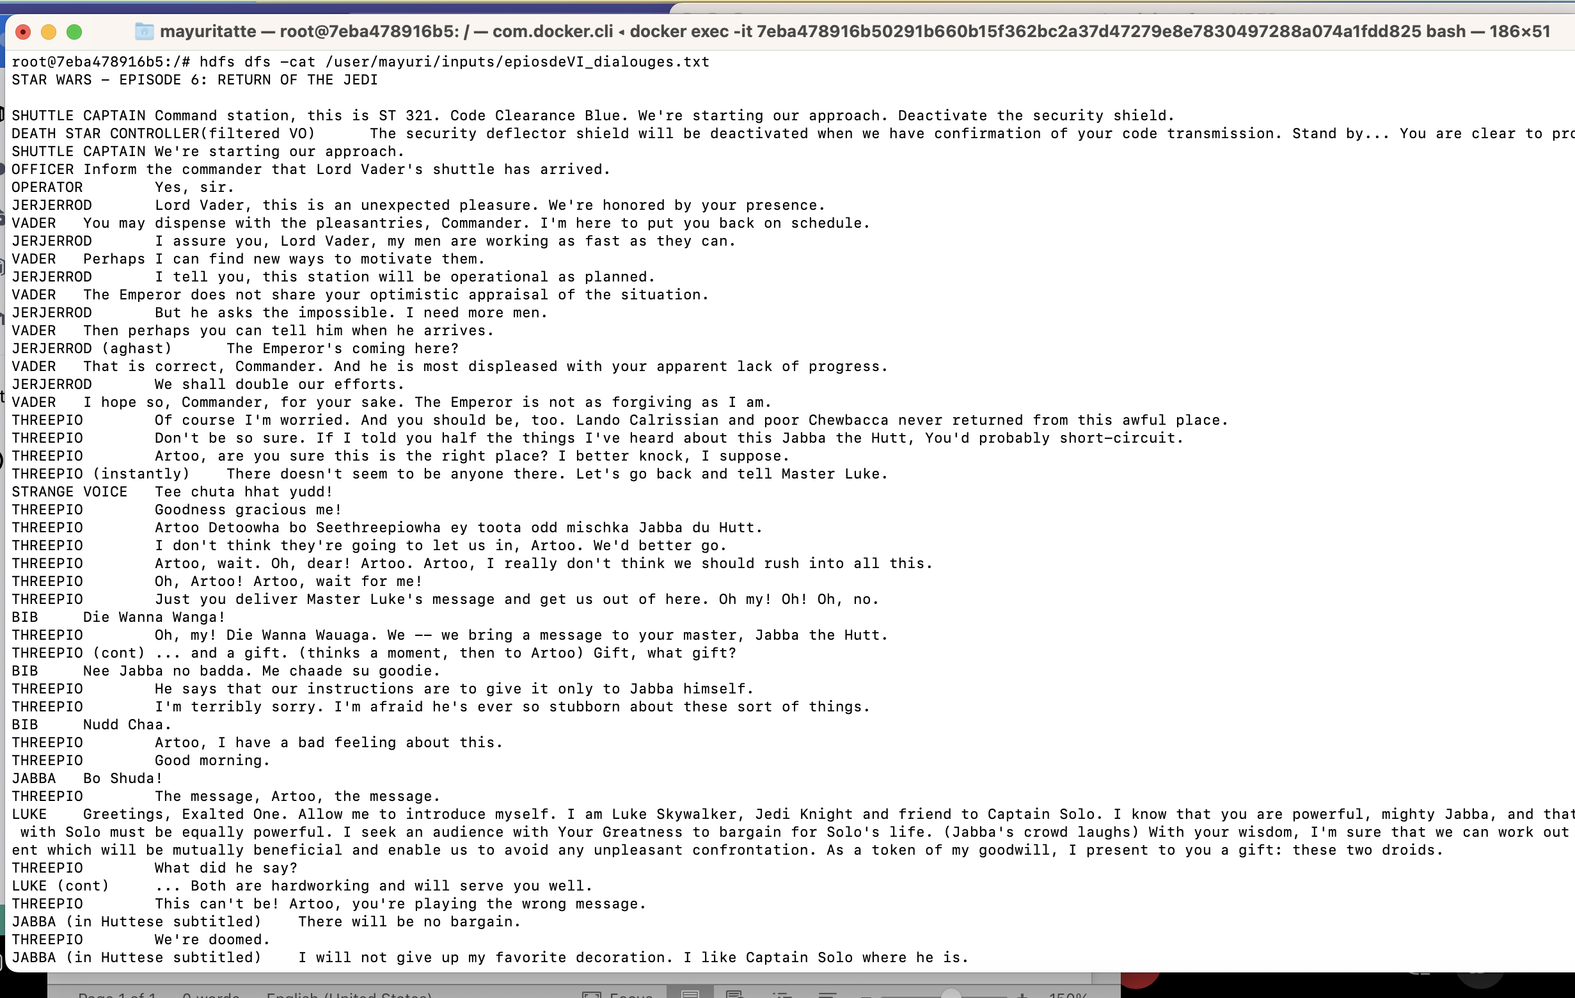

Loaded files into HDFS –

Pig script –

Executed pig script but due to environment issues was getting below issue on Mac

